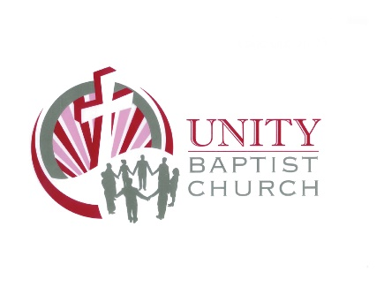
Classification: Youth Ministry Leader
Part time or possible Full-time
*Candidate must be willing to adhere to the Southern Baptist Faith and Message and submit to a Background Check
Salary: Negotiable
Church Name:
Unity Baptist Church
980 Unity Church Rd.
Jamestown, Tn. 38556

Contact Person:
Senior Pastor, Raymond Phillips
Contact E-mail Address:
raymond@unitybaptistchurch.net
Contact Phone Number:
Office: 931-879-4904
*Text/Call: 931-267-0606
Description/Responsibilities:
• Conduct student Bible studies on Sunday @9:45am, Wed. 7pm.
• Be alert to win the lost and instructing students in reaching the unchurched.
• Work with Senior pastor, volunteer staff, appropriate ministry directors and program leaders in dreaming, planning, evaluating and coordinating all student ministries of the church.
• Plan attend/direct monthly student activities designed to connect them to each other and the work of the church, including, but not limited to, student fellowships, retreats and mission trips.
• Assist with Evening Vacation Bible School during summer. 6-8pm (one week per yr.)
Requirements/Qualifications:
*Feel the Call of God to serve in ministry
• Biblically guided and Spirit led.
• Spiritual passion to pursue and maintain a godly walk with God.
• Possess a level of spiritual maturity and genuine love for students.
• A passion to disciple the youth and mature them in their walk of faith.
Character Qualifications:
• Provide 2 Character references on application from church where you have served if possible
• Maintain biblical, moral and ethical standards.
Job Skill Qualifications:
• Ability to communicate with clarity and passion.
• Discipleship and mentoring capabilities.
• Basic organizational and administrative skills necessary for the job.
Application Instructions:
Send email to request application or call church office: 931-879-4904
Church Website Address:
http://www.unitybaptistchurch.net

